|  |
| --- |
|  |
| download.png |
| Bookings Analysis REPORT |
|  |
| **Tools and technologies used:** |
| **SQL, MYSQL, MICROSOFT-EXCEL, POWER-BI** |

|  |
| --- |
|  |

OBJECTIVE: Analyzed OLA rides bookings data to identify key trends, patterns, and actionable insights to improve operational efficiency and customer satisfaction thereby increasing booking rate.

STEP-1: Identifying the problem statement which here is ‘Increasing rates of ride cancellation’.

STEP-2: Collected data from multiple sources (kaggle, Google dataset) and cleaned the data to remove any cases of duplicacy or null values.

STEP-3: Applied key SQL queries to derive meaningful insights from the data using MYSQL.

The queries applied were as follows which helped to answer relevant questions :

1. **Retrieve all successful bookings:**

**SELECT * FROM bookings WHERE Booking_Status = 'Success';**

1. **Find the average ride distance for each vehicle type:**

**SELECT Vehicle_Type, AVG(Ride_Distance) as avg_distance FROM bookings**

**GROUP BY Vehicle_Type;**

1. **List the top 5 customers who booked the highest number of rides:**

**SELECT Customer_ID, COUNT(Booking_ID) as total_rides FROM bookings**

**GROUP BY Customer_ID**

**ORDER BY total_rides DESC LIMIT 5;**

1. **Get the number of rides cancelled by drivers due to personal and car-related issues:**

**SELECT COUNT(*) FROM bookings**

**WHERE cancelled_Rides_by_Driver = 'Personal & Car related issue';**

1. **Find the maximum and minimum driver ratings for Prime Sedan bookings:**

**SELECT MAX(Driver_Ratings) as max_rating, MIN(Driver_Ratings) as min_rating**

**FROM bookings WHERE Vehicle_Type = 'Prime Sedan';**

1. **Retrieve all rides where payment was made using UPI:**

**SELECT * FROM bookings WHERE Payment_Method = 'UPI';**

1. **Find the average customer rating per vehicle type:**

**SELECT Vehicle_Type, AVG(Customer_Rating) as avg_customer_rating**

**FROM bookings**

**GROUP BY Vehicle_Type;**

1. **Calculate the total booking value of rides completed successfully:**

**SELECT SUM(Booking_Value) as total_successful_value**

**FROM bookings**

**WHERE Booking_Status = 'Success';**

1. **List all incomplete rides along with the reason:**

**SELECT Booking_ID, Incomplete_Rides_Reason**

**FROM bookings**

**WHERE Incomplete_Rides ='Yes';**

1. **Get the total number of cancelled rides by customers:**

**SELECT COUNT(*) FROM bookings**

**WHERE Booking_Status = 'cancelled by Customer';**

STEP-4: Visualizing the data using POWER-BI responsive Dashboards:

1.Overall dashboard:

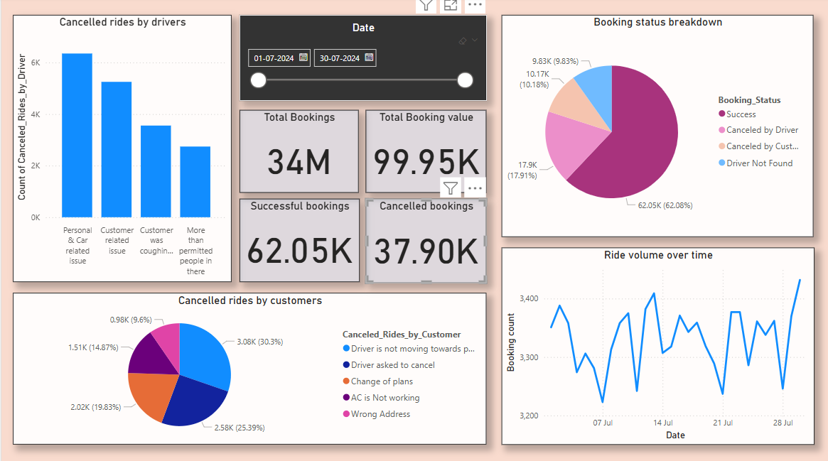

Conclusions drawn-

1. Majority rides were success (approax 62%).

2. A large number of rides fall into category of ‘Cancelled by Driver’ which becomes an important point to consider. Better communication and policy changes would reduce such issues.

3. Ride volume becomes maximum on weekends (peak-demands).

4. In cases where drivers cancel the rides ‘Car related issues’ dominate the reason behind it. Proper takecare and servicing of vehicles would improve any future instances of the same.

2. Trends dashboard:

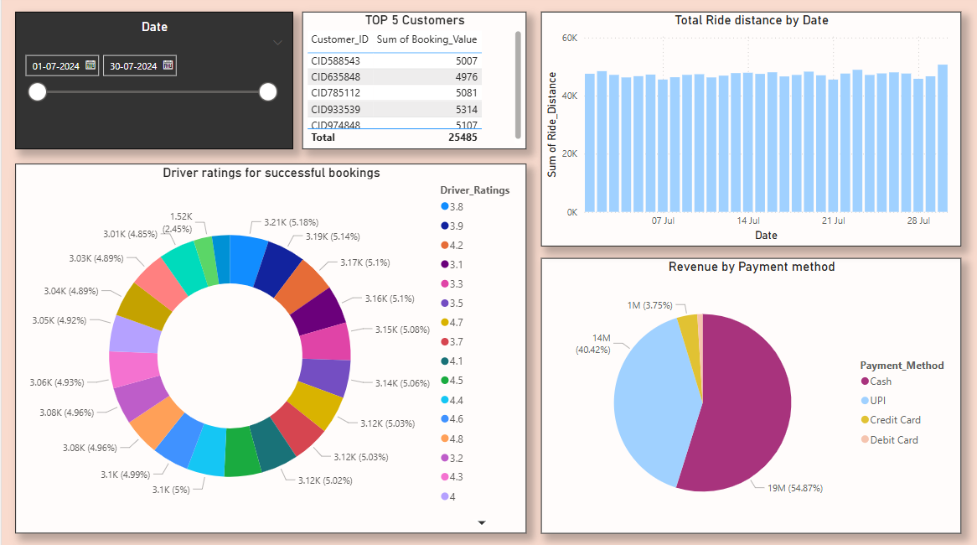

Conclusions drawn-

1. The bar graph shows that the average ride distance was observed to be almost same (Uniformly distributed).

2. Data of the top 5 customers was obtained as a table. There could be policies made to provide them plans or memberships and offer discounts so that they would continue booking rides with Ola.

3. It was seen that most of the customers chose cash over other payment options. UPI transactions followed up.

4. The highest driver rating went up as high as 4.8 while the lowest rating was seen to be 3.2.

Summary:

* Providing incentives to the top-booking customers, Service and maintenance of the vehicles, proper addressing of the driver issues would decrease cancellation rates by almost **10%.**
* Ride volumes fluctuate over time, with identifiable peaks during **high peak hours**, indicating opportunities for surge pricing and better resource allocation during these times.
* Analysis of **driver ratings** reveals patterns of performance, helping identify **top-performing drivers** and those needing improvement.
* Optimizing the **driver allocation system** to reduce cancellations due to unavailability and introducing some facilities for high rated drivers would help.
* Address common customer cancellation reasons through **app-design improvements**, better communication and **customer support system.**